Assignee evaluation criteria:
- Assignee should be able to answer the real time usages of all points mentioned below.
- This is mainly designed to write the code on any points mentioned below.
Few examples for reference:
- Write a program to transfer the file1.txt content into file2.txt.
- Print 1 to 100 with two threads, first thread can only print even number and second thread can only print odd number.
- Sort Employee object with name & age using Comparator and Comparable.
- Write few real time examples where you can use Custom checked or unchecked exception.
- Write a code where you can use instance/static variable, block & method.
- Store data into collection API and retrieve/print using multiple ways.
- Coding on java8 related features mentioned below.
- And many others.

- Know how JDK, JRE and JVM work.
Resources:
https://www.betsol.com/blog/java-memory-management-for-java-virtual-machine-jvm/

https://medium.com/@kiranchowdhary/java-memory-management-and-garbage-collection-e29d3c313d05

https://dzone.com/articles/java-memory-management

https://www.digitalocean.com/community/tutorials/java-jvm-memory-model-memory-management-in-java

- Different kinds of Java ClassLoader with hands-on.

- Usages of list of java keywords:
Data Types - byte, short, int, long, float, double, char, Boolean (8)
Flow-Control: - if, else, switch, case, default, break, for, while, do-while, continue (10)
Method-level: - void, return (2)
Object-level: - new, this, super, instanceof (4)
Source-file: class, extends, interface, implements, package, import (6)
Exception handling: - try, catch, finally, throw, throws (5)
1.5 version: - enum, assert (2)
Modifiers: - public, private, protected, abstract, final, static strictfp, native
, transient, volatile, synchronized (11)
Predefined constants: True, false, null (3)
Unused: - goto, const (2)

Keywords (50) + constants (3) = Reserved Words (53)

- Data Type, their size & default value
byte - 1byte (ok -> byte b = 127; Wrong -> byte b = 128 +)
short - 2bytes (max - 32767)
char - 2bytes.
boolean - 1bit
int/float - 4bytes
long/double - 8bytes
Reference Type – 8 bytes

- Wrapper Data Type
Hands-on on all wrapper classes.

Autoboxing (Primitive to Wrapper) vs Unboxing (Wrapper to Primitive)
Autoboxing:
int a=20;
Integer i=Integer.valueOf(a);//converting int into Integer explicitly

Integer j=a;
//autoboxing, now compiler will write Integer.valueOf(a) internally
Unboxing:
Integer a=new Integer (3);
int i=a.intValue();//converting Integer to int explicitly

int j=a;//unboxing, now compiler will write a.intValue() internally

Their conversation
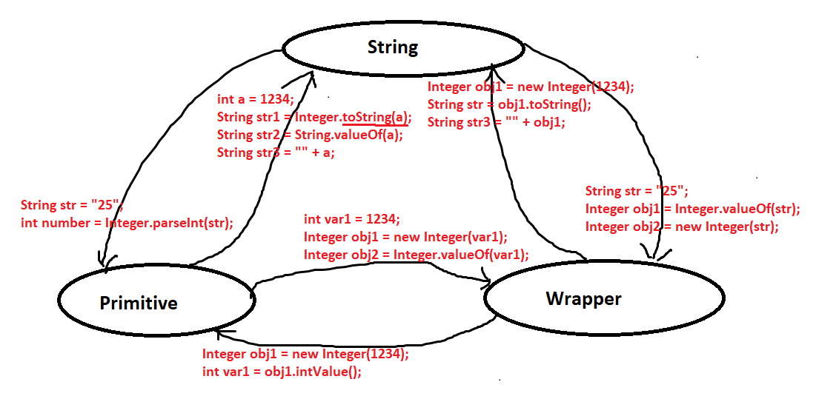

Objective of these data types.

Boolean/Character/Byte/Short/Integer/Long/ Float /Double

- Java Type Casting:
Widening Casting (automatically) - converting a smaller type to a larger type size
byte -> short -> char -> int -> long -> float -> double
Narrowing Casting (manually) - converting a larger type to a smaller size type
double -> float -> long -> int -> char -> short -> byte

int I = 130;
byte b =(byte)I;

- OOPS
- Abstraction, Encapsulation, Inheritance and Polymorphism
- Overriding vs dynamic dispatch
- Usages of super & this with hands-on.
- Inheritance + Overriding + Exception.
- call by value vs Call by ref.
- Constructor vs method
- Constructor chaining, Static and Instance block.

Emp –
private int age , //setter & getter
public int age

emp.age = 20
emp.setAge(30)

Animal a = new Dog()
a.walk()

Dog extends A,B,C

Dog implements X,Y,Z

Static block called when your class is loaded, and your class is first loaded by class loader in jvm so first they get executed.

then you create object, so your parent init/Instance block is called then your parent constructor due to constructor chaining in java then derived class init/Instance block then derived class constructor.

Instance variable, block, method
Static variable, block, method
Constructor

Emp{
{

}

static{
}

Private int age;
Private Static String name;

}

- Instance & Static method, instance, and static variable.
- From Static context can’t be called none-static. Bcoz non-static will not be available during the class load.
- But from non-static context, static can be called. Since it will be available by this time.
- Whenever you want a variable to be shared by all the objects of the same class, you mark that variable static. Non-static variables are not shareable between objects.
class Student {
//static variable
private static int numberOfStudentEnrolled= 0;
//non- static ( instance variable)
private String name;
//Constructor
public Student(String name){
this.name = name;
}
}
Student peter = new Student(“Peter”);
Student john = new Student(“John”);
Student linda = new Student(“Linda”);

All students Peter, John and Linda objects are in different memory on the heap and have their own copy of “String name” variable. So, in every memory, name is unique and not sharable to each other.

Whereas the static variable “static int numberOfStudentEnrolled” is seen by all the objects peter, john and linda. Means, all objects will see the same value of numberOfStudentEnrolled.
- A static Block:
We use a static block to initialize static variables. Although we can initialize static variables directly during declaration, there are situations when we need to do multiline processing. In such cases, static blocks come in handy.
If static variables require additional, multi-statement logic during initialization, we can use a static block.

The purpose of using a static initialization block is to write that logic inside static block that is executed during the class loading.

- enum & class
- hashCode, equals, getClass() & toString
- primitive arrays vs arraylist
- HAS-A & IS-A
- Final class & Final variable
- Local variable
- Runtime Polymorphism or Dynamic Polymorphism
- Dynamic Dispatch method

String str1 =”www”;
str1 = str1 +”ss”;

- Conditions – Ternary è ? :
- Loops: for, while, do-while.
- Exception –
- final, finally, finalize.
- Throw, throws.
- Checked & unchecked.
- Custom checked & Unchecked exception.

- Threading
- Thread, Runnable (run method), Callable (call method), Future
- Volatile, synchronize, wait, notify, notifyAll, sleep.
- Executors, submit overloaded method -> Runnable task or Callable task.
- CompletableFuture:
Asynchronous Computation -> CompletableFuture<String> completableFuture
= CompletableFuture.supplyAsync(() -> "Hello")
.thenCompose(s -> CompletableFuture.supplyAsync(() -> s + " World"));
assertEquals("Hello World", completableFuture.get());
Deadlocks, Reentrant Lock and Unlock, Thread Starvation

- Inner classes:
- Static Inner Classes with Static Members
- Static Inner Classes with Non-Static Members
- Non-Static Inner Classes
- Accessing Outer Class Members
- Local Inner Classes
- Anonymous Inner Classes
- Anonymous Connection Class
- Anonymous Runnable Class
- Collections:
- normal vs generic
- Collection Hierarchy
- List, Set & Map
- Collections & Arrays
- Loop, Enumarator & Iterator
- Comparable[a.compareTo(b)] & Comparator[compare(a,b)]
- CopyOnWriteArrayList, CopyOnWriteArraySet, ConcurrentHashMap, BlockingQueue& Producer Consumer Pattern
- IO:
- All hands-on byte’s stream classes & interfaces.
- All hands-on character stream classes & interfaces.
- Byte Stream vs Character Stream
Byte Stream
They process the data byte by byte.
They read/write data 8 bits maximum at a time.
They are most suitable to process binary files.
All byte stream classes in Java are descendants of InputStream and OutputStream.
Character Stream
They process the data character by character.
They read/write data 16 bits maximum at a time.
They are most suitable to process text files.
All character stream classes in Java are descendants of Reader and Writer.
- Serializable, deserializable, externalizable & transient.

- Java8 features:
Lambda Expressions
Lambda expressions are nothing but the implementation of the functional interface. A functional interface is nothing but an interface that has only one abstract method. To declare an interface as a functional interface, Java provides an annotation @FunctionalInterface.

@FunctionalInterface
interface MyInterface{

// abstract method
double getPiValue();
}

MyInterface ref;
// declare a reference to MyInterface
MyInterface ref;

// lambda expression
ref = () -> 3.1415;
System.out.println("Value of Pi = " + ref.getPiValue());

Functional Interfaces & creates custom.
Functional Interface is nothing but just an interface with a "single abstract method", also commonly termed as SAM. They are annotated with @FuctionalInterface annotation. These interfaces also act as a target type for lambda expressions.

Default methods in interfaces

FI - Function/Supplier/Consumer/Predicate
Supplier ref = () -> 3.1415;
Predicate ageP = (Employee emp) -> emp.getAge()>40;
ageP.test()

Predicates:
The Predicate in Java 8 is one of the types of Functional Interfaces. Functional Interfaces were introduced in Java 8 to support functional programming in the object-oriented world of Java. The Predicate is one of them, which allows programmers to test a specific condition imposed on values or objects. Such a condition will always return a boolean value.
@FuncionalInterface
public interface Predicate<T> {
...
boolean test(T t);

// rest methods
...
}
public class MyCustomPredicate implements Predicate<Integer> {
@Override
public boolean test(Integer t) {
return t >= 18 && t < 25;
}
}
MyCustomPredicate obj1 = new MyCustomPredicate();
obj1.test(20);// true

The term "predicate" implies a statement that evaluates whether a value is true or false.
Method Referencing using :: Operator.
Streams/map/filter/flatmap
Optional
Date & Time API
CompletableFunture

